Make your own self-soothe box

When we are feeling anxious, low or distressed we can get caught up in negative thoughts and how bad we are feeling. It can be helpful to have your very own self-soothe box, which you can fill with different things to distract you and help you to feel better in those moments. The idea with this box is to include things which soothe all five of our senses, helping us to feel better in all sorts of ways and take us out of our head and how we are feeling.
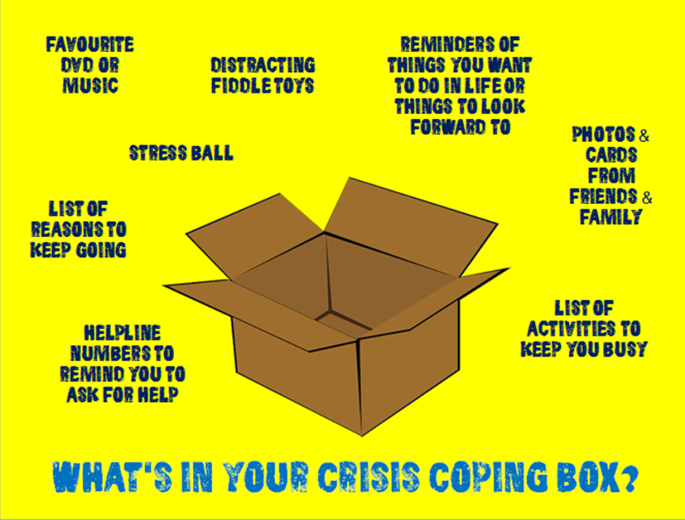
- Get an empty box from around the house (an old shoe box works well) or you can buy one from a craft shop
Top tip: Ideally the box will fit under your bed or in a cupboard as a personal thing just for you
- Decorate the box inside and out with anything you like- it could be coloured, painted, decorated with wrapping paper, fabric or decoupage. Make something that appeals to you!
Top tip: You can also put some tissue paper on the bottom which can give it a nice comforting feel
- Collect items together that are meaningful to you, or you know will help you feel better. Remember these should be soothing for all 5 senses. Here are some ideas:

SEE: photos of people you love and care about or of fun memories, snow globe, glitter jar, DVD of your favourite films or TV shows, book or magazine, a picture of a beautiful place or cute animals, a drawing you love, a reminder for funny or inspiring YouTube videos or games on your phone, letters or cards from your friends and/or family. You could make yourself a card with positive coping statements – which you can read or say to yourself to help you get through the distress.
HEAR: your favourite music, songs that you know lift your mood, relaxing music, recordings of a friend’s voice, a reminder of people that you can call and talk to, audio book, reminders for podcasts. You can write a list of these things to put in your box as a reminder.

 TOUCH: bubble wrap, a teddy bear, a pillow, soft woolly socks or blanket, nail varnish, hair brush, a reminder to have a bubble bath or a shower (you could even put in nice smelling shower gel or a bath bomb), a reminder to cuddle your pet. You could have distraction fiddle toys or objects like that you like to touch (e.g., stones/ pebbles, pine cones, feathers).

SMELL: Favourite perfume or body spray, candles, a fruity bubble bath or a nice smelling soap.

TASTE: dried fruit or nuts, hot chocolate, sweets, your favourite chocolate. Crunchy, chewy, salty, sweet- what’s your preference?

Top tips:
If you can’t fit or keep something in the box (e.g. iPad/tablet, phone, music, laptop), then perhaps use a reminder of the item, e.g. have a picture of the item or have it written down on a piece of card.

Some of these things can do more than one sense at a time, e.g. you can use a nice smelling hand lotion for smell and touch.

- Here are some other things that you can include, to help as a distraction or to keep you occupied: activity books (colouring, crosswords, wordsearch, sudoku), art and craft materials, notebook or diary and a pen.
- Try to think of anything else you can include which you know you enjoy or would help when you are struggling.
When you use these items, or if you choose to do something else that works, try to make sure you pay attention to your physical senses: see, hear, smell or taste, and touch. Look around you and notice what you see (colours, shapes, light or shadow, movement), what you hear (nature sounds, sounds in the room, near and far), what you smell or taste (including from the environment around you), and what you can touch – right now, wherever you are as well as items from your self-soothe box.

