Belong. Aspire. Achieve.

CAREERS ACCESS POLICY STATEMENT
2024 - 2025

Reviewer: | Business Manager
Review date: | 4/12/24
Committee:  Next review: | CSE  December 2026

Registered Academy Company No. 08036151
Registered address: London Road, Holybourne, Alton, Hampshire, GU34 4EQ
www.eggars.net

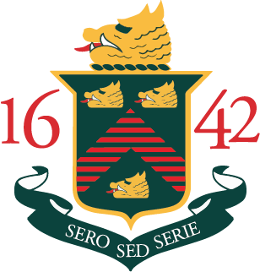



Eggar’s School (The School) collects and uses your child’s biometric data. The School will use the data for catering purposes. The School’s lawful basis for the use of your child’s biometric data is your written consent. The School may share your child’s biometric data with Civica, our Cashless Catering provider. The School will keep your child’s biometric data in accordance with the School’s retention schedule. You have some legal rights in respect of the biometric data we collect from your child. Please see the School’s general privacy notice on our website for further details. You can contact the School’s Data Protection Officer at:
enquires@eggars.hants.sch.uk
If you have a concern about the way we are collecting or using your child’s biometric data, you should raise your concern with us in the first instance or directly to the Information Commissioner’s Office at:
https://ico.org.uk/concerns/

